Honors Project

Tails of the town

Sarah Anderson (Sally)

2021

Honors Project

Sally Anderson 4/2/2021

Tails Of The Town

Pet groomer

Development of React Web app.

1. Single page application with sticky navbar at the top.
2. Home page
   1. links to the other pages from navbar and from body
      1. image, brief description, and link to the corresponding page
   2. Carousel for reviews
3. About us page
   1. links to the other pages from navbar
   2. image, Description of who they are and what they do.
4. Service page
   1. links to the other pages from navbar and from body
   2. image, description of services and pricing
5. Contact page --
   1. links to the other pages from navbar
   2. Send email
6. Photo Gallery and Testimonials/Reviews
   1. links to the other pages from navbar
   2. images of their clients

Tails Of The Town is a local dog and cat grooming salon. Their only web/internet presence is Facebook. I talked with the owner Carla Sadler when getting one of my dogs groomed about using her and her business for my class project. I have been working with her throughout this project. When the project is finally complete, we will find a hosting site and go live with it. Carla and myself are very excited about this.

In the images below is my initial design and what I did in Bootstrap. My React project was going to switch the project over from HTML/CSS/JS. Throughout the project the design has been changing, here is a list of some of the things, some were owner driven and some I initiated.

Layout Changes:

* Color scheme changed
* Jumbotron removed
* Footer removed
* Google Map removed
* Login and booking removed
* Gallery to be a full page of the pictures
* Make carousel of customer reviews on homepage
* Update pricing information
* Update Photos
* Add background – (Will need to find another or buy this one – watermark)
* Changed Navbar
  + Name and logo on the left
  + Links on the right
  + Change icons on links to paws
  + Make the Name the link to homepage
* Add picture links to homepage
  + Add new thumbnails

Things to do before it goes live

* Get real email setup and working
* Ability to post actual customer reviews

Initial Design

Home Page

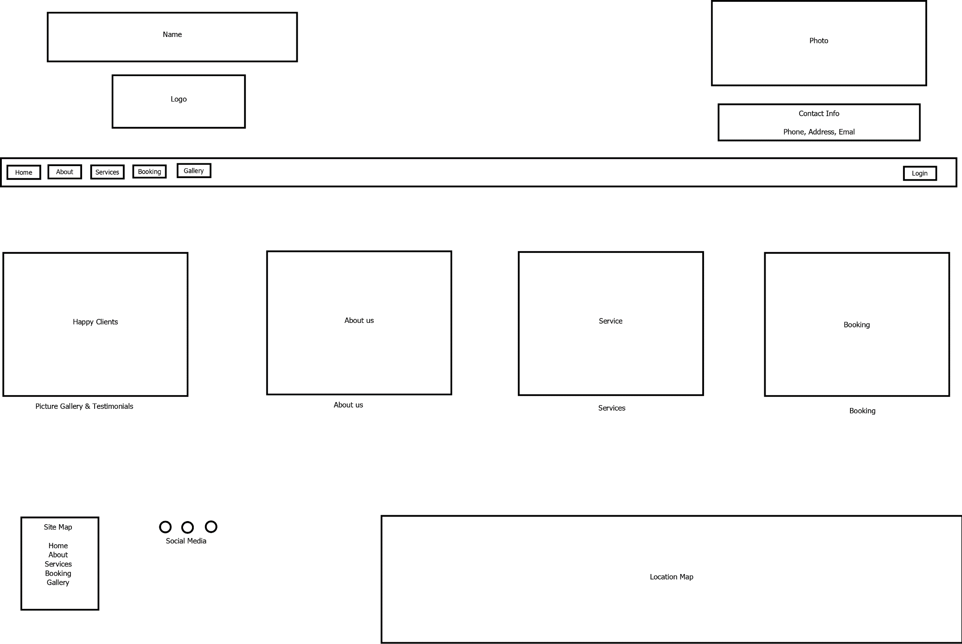

About us

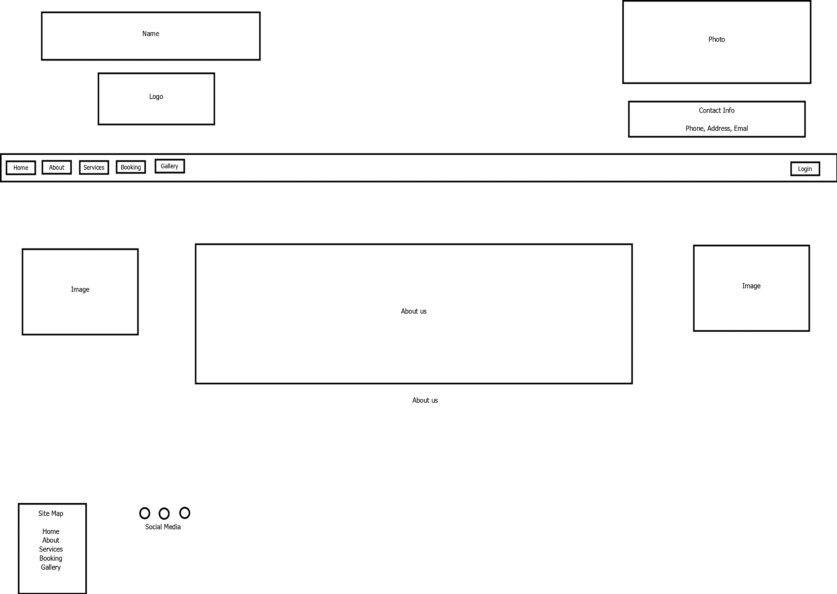

Service

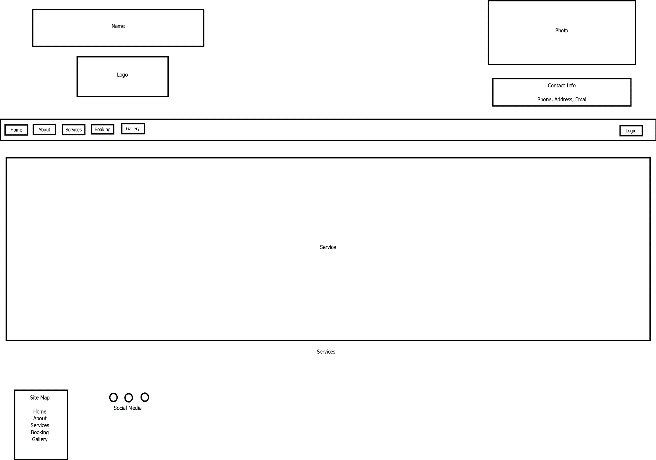

Booking

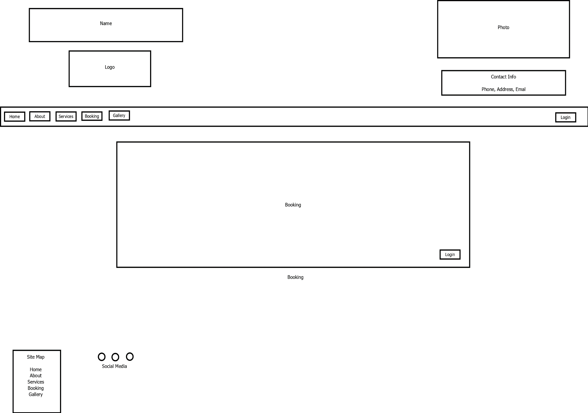

Picture Gallery & Testimonials/Reviews

